 | Year 10 Mathematics  Test 3, 2021  Topic – Pythagoras theorem and Trigonometry in 90º | 33  = %
Weighting | 5% of Total Grade | 40 minutes
Resources allowed for Section 2 | 1 Page hand written notes (unfolded), Scientific calculator, Approved Stationery

- Find the value of the missing side [6 marks]
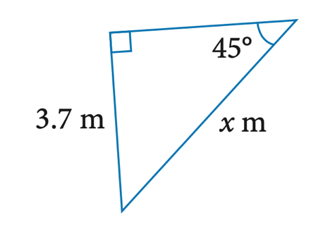
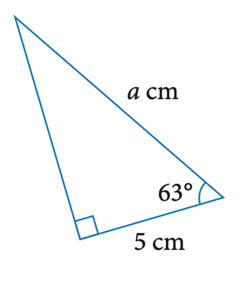

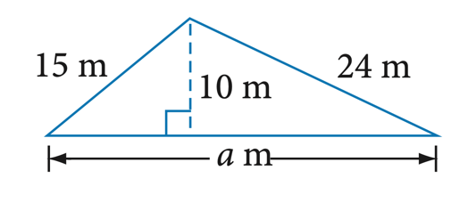

- Determine the angle of the upper storey carpark ramp in the diagram below. [3 marks]
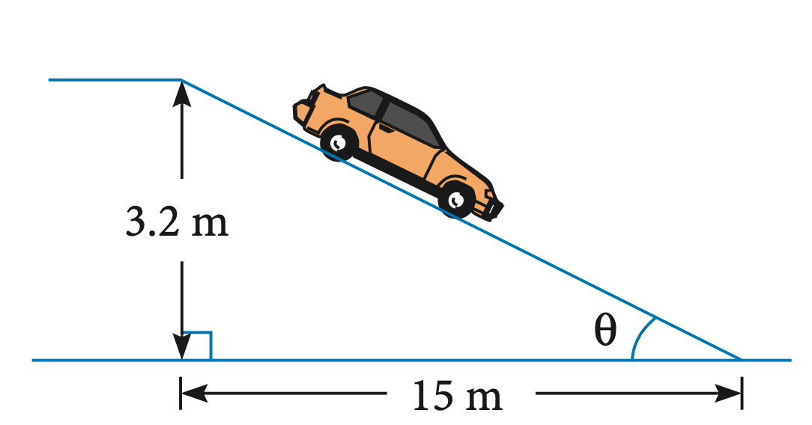

- A ship sails south easterly for 20km, and until it is 15km due east of its starting position. [2+1 marks]
  - How far south is the ship from its original position?

  - What is the bearing of return for the ship to go back to the origin?

- A Pencil is placed in a tennis ball tube and has been sharped so that it sits flush with the top of the cannister. Determine the length of the pencil. [2 marks]
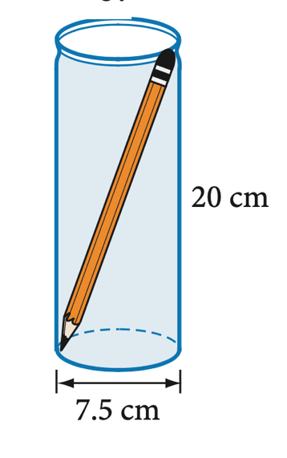

- A Kite is tied to a railing that is 1.2m above the ground. The kite string is 25m long and is 17m horizontally to the ground. Determine the total distance from the kite to the ground. [5 marks]

- A Surveyor travels along a road, but has to make a detour around a flooded river. He travels on a bearing of 128ºT. After 8 kms, he drives on a bearing of 056ºT until he returns to the main road. Using the diagram below, determine all angles for the Triangle ABC [4 marks]
C
A

B

- Equal access ramps have to be built at a rise to run ratio of 2 : 30. [2 + 2 = 4 Marks]
  - Determine the angle of elevation for this ramp.

  - If a ramp has a total travel distance of 2.6m in length, determine the corresponding side lengths

- Amy and Travis are planning a trip bluff knoll in the holidays. At the peak, they see a viewing platform atop a tree that they climbed the previous day that was 150m tall.
Determine the angle of depression from the top of the knoll to the top of the tree. [6 Marks]
